VoiceTRX100 – Quick Start Guide

Contents

Contents 1

Introduction 5

Supported Hardware 5

PTZ Cameras 5

Video Switchers 5

Microphones 5

Zones Explained 6

Connecting to the VoiceTRX100 6

Directly 6

Via LAN 7

Microphone Modules 7

Sennheiser TCC M 7

Preparation 7

Discover the microphone and access the configuration UI 8

Enable third party access 8

Zone Settings 9

Audio Settings 10

VoiceTRX100 Configuration 12

Sennheiser TCC 2 17

Preparation 17

Discover the microphone and access the configuration UI 17

Zone Settings 17

Audio Settings 19

VoiceTRX100 Configuration 20

Audio-Technica ATND1061 24

Preparation 24

Discover the microphone and access the configuration UI 24

Enable third party access 25

Coverage and Camera Zone configuration 26

VoiceTRX100 Configuration 28

Shure MXA 920 (Automatic Coverage) 30

Preparation 30

Discover the microphone and access the configuration UI 30

Coverage 31

VoiceTRX100 Configuration 32

Shure MXA 910/920 (Lobe gating mode) 37

Preparation 37

Discover the microphone and access the configuration UI 37

Coverage 38

Auto Positioning 39

Lobe width 40

IntelliMix 41

VoiceTRX100 Configuration 43

Shure MXW 45

Supported receivers 45

Preparation 45

Discover the receiver and access the configuration UI 45

Switch behaviour 46

VoiceTRX100 Configuration 47

Shure MXCW 49

Preparation 49

Discover the conference unit and access the configuration UI 49

Meeting Controls 50

VoiceTRX100 Configuration 51

Sennheiser Speech line 53

Supported receivers 53

Preparation 53

Discover the microphone and access the configuration UI 53

Switch behaviour 54

VoiceTRX100 Configuration 54

Generic TCP Input 57

VoiceTRX100 Configuration 57

Audio-Technica ATUC-50/ATUC-IR 59

Preparation 59

Discover the conference unit and access the configuration UI 59

Meeting Controls 60

VoiceTRX100 Configuration 61

Switcher Modules 64

Datavideo iCast-10NDI 64

Preparation 64

VoiceTRX100 Configuration 64

Datavideo KMU-100+ 66

Preparation 66

VoiceTRX100 Configuration 66

Datavideo SE-2600/3200/4000 series 68

Preparation 68

VoiceTRX100 Configuration 68

Internal NDI SwitchHub 69

VoiceTRX100 Configuration 69

Camera Modules 71

Datavideo PTC Series 71

Preparation 71

VoiceTRX100 Configuration 71

Actions 72

Simple Mode 73

Advanced Mode 73

Network 73

System 74

Microphone Tie 75

Configuration 75

Behaviour and best Practices 76

Far End Detection 76

Supported DANTE adapters 76

Configuration 77

Behaviour 78

Profile 78

DVIP Control Protocol 78

Discovery and IP configuration 79

DVIP command structure 79

Device specific commands 79

HTTP Control Protocol 80

Factory Reset 80

# Introduction

In addition to this quick start guide, detailed tutorials can be found on the Datavideo Academy website [www.datavideoacademy.com](http://www.datavideoacademy.com).

# Supported Hardware

## PTZ Cameras

* Datavideo PTC-140 HD Series
* Datavideo PTC-145 HD Series
* Datavideo PTC-285 4K Series
* Datavideo PTC-305 4K Series

## Video Switchers

* Internal NDI SwitchHub (License required)
* Datavideo KMU-100+
* Datavideo iCast-10NDI
* Datavideo SE-2600/3200/4000 Series

## Microphones

**Type:** Ceiling Microphone, Wireless Microphone or Conferencing system

**Supported Microphones:** Applicable to Wireless Microphone systems only, defines the types of supported microphone transmitters.

**Max Zones:** Maximum number of zones supported by a single microphone or receiver.

**Multiple Zones:** Is the microphone or receiver capable of reporting more than one active position.

**Far end detection:** Can the microphone provide VoiceTrx-100 with data to detect far end activity via its AEC/Reference input. **Please Note:** All microphones can support far end detection with an optional DANTE adapter, please see the ‘Far end detection’ section of this guide.

# Zones Explained

The VoiceTRX-100 operates using zones no matter what microphone system is used, a lobe, position, audio channel or physical microphone will be mapped to a zone, and the zone is what triggers actions on the VoiceTRX-100.

In addition to the positive zones (zone 1 onwards) there are also three negative zones that are used internally by the VoiceTRX-100, all negative zones reported by microphone modules are treated the same, that means that any negative zone will trigger the ‘Home Zone’.

|  |  |
| --- | --- |
| **Zone** | **Description** |
| -1 | Home zone, mic mics have been active for the home period. |
| -2 | Far end, the far end has been triggered. |
| -3 | Multiple, more than one zone is active. |

# Connecting to the VoiceTRX100

## Directly

By default, the VoiceTRX100 will output its control UI on HDMI port 1 or 2, the port that is connected when the VoiceTRX100 is powered on will be used.

1. Connect HDMI 2 to a monitor.
2. Connect a USB keyboard and mouse to the VoiceTRX100.
3. Login with the default credentials User: admin Pass: admin.

## Via LAN

The VoiceTRX100 will automatically be assigned an IP address when connected to a network that supports DHCP, if the network does not support DHCP we recommend connecting directly to configure the static IP as above.

If using DHCP, you can discover the IP address of the VoiceTRX using the free DVIP tool. You can download the Windows DVIP Configuration Tool from the link below.

<https://www.datavideo.com/global/product/DVIP>

The tool is also available via the Google Play Store and Apple App store.

1. Connect your computer to same the LAN as the VoiceTRX100, ensure your computer is on DHCP so its assigned an IP address in the same range as the VoiceTRX100.
2. Open a web browser and navigate to the IP address of the VoiceTRX100. We strongly recommend you use the **Google Chrome** web browser.
3. Login with the default credentials User: admin Pass: admin.

# Microphone Modules

## Sennheiser TCC M

Preparation

Initial configuration: A router or managed switch with a DHCP server function will be required to set the Network settings.

Network Connections: Install the Sennheiser TCC M, VoiceTRX100 processor, PTZ cameras and video switcher in the same local area network.

Installation Location: Decide on the installation location for the Sennheiser TCC M. Choose a location that captures the participants' voices while considering the camera's field of view.

Firmware Updates: Ensure that the Sennheiser TCC M and all Datavideo equipment is updated to the latest version before configuration.

Discover the microphone and access the configuration UI

1. Download and install the Sennheiser ‘Control Cockpit’ software <https://www.sennheiser.com/en-us/catalog/applications/assistive-listening-and-audience-engagement/control-cockpit/control-cockpit-111111>
2. Open ‘Control Cockpit’ and navigate to the ‘Devices Tab’
3. If the TCC Mis not listed, you can add it manually using its IP address
4. Click the TCC2 microphones name to access its settings

Enable third party access

1. Navigate to the ‘Access’ tab

2. Enable third party access

3. Enter a Password and click ‘OK’ to save. Make note of the chosen password, you will need it to connect the TCC M to the VoiceTRX100 later

Zone Settings

The Sennheiser TCC M supports two types of zones:

**Exclusion Zones**

Exclusion Zones enable you to eliminate unwanted sources of constant noise. Up to five exclusion zones are supported. It is recommended to exclude any areas that will not be actively used.

Adjust the sliders to set a vertical and horizontal zone. The vertical zone can be adjusted from 0° to 90°, the Horizontal zone can be adjusted from 0° to 360°.

**Priority Zones**

The Priority Zone is used to keep the focus on the moderator's voice. The priority zone take priority over non-priority zones. One priority zone is supported, the ‘Weight’ can be set as follows:

**Mid:** Increases the weighting on the audio output from the selected zone by approximately 1.5 times the normal value.

**High:** Increases the weighting on the audio output from the selected zone by approximately 2 times the normal value.

**Max:** Increases the weighting on the audio output from the selected zone by approximately 3 times the normal value.

**3D Overall View**

The 3D view will display the current beam position (loudest speaker) and priority / exclusion zones in real time.

Priority zones are shown in green; exclusion zones are shown in dark blue. If both types of zone overlap, the exclusion zones will override the priority zone.

Audio Settings

**Installation Type**

Please ensure you set the appropriate installation type.

**Flush Mount:** The microphone array has been installed in or directly underneath the ceiling.

**Suspended mount:** The microphone array has been suspended from the ceiling.

**Noise Gate**

The noise gate function prevents the TCC M microphone from picking up unwanted background noise.

Threshold: The Noise Gate will open the audio output only after the audio level exceeds the set threshold for the set period.

**Sensitivity Threshold**

The Sensitivity Threshold setting lets you adjust the TCC M microphone's sensitivity to background noise to better identify the presenter. Depending on the setting, the sensitivity is either amplified or attenuated.

**Normal(default):** Recommended for speakers with a normal speaking volume.

**Quiet:** Recommended for speakers with a quiet speaking volume. The sensitivity of the microphone is increased.

**Loud:** Recommended for speakers with a loud speaking volume. The sensitivity of the microphone is attenuated.

**Intelligent Noise Control**

Detects and suppresses unwanted static background noise in noisy environments for enhanced voice tracking. Enabling this feature is recommended if there is static background noise from fans, HVAC etc, the low settings is sufficient for most applications.

VoiceTRX100 Configuration

**Connecting the Sennheiser TCC M microphone**

1. Click the ‘Device Menu’ and then ‘Mic Pool’

1. Click the ‘Add Manually’ button under the ‘Mic Pool’ heading.

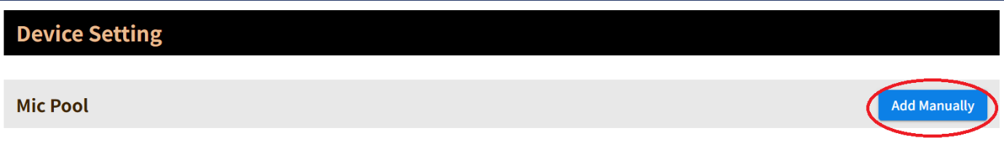

1. Select ‘Sennheiser TCC M’ from the dropdown menu, enter a friendly name and the IP address of the Sennheiser TCC M microphone.

1. Click the ‘Add’ button.
2. You will see the microphone listed as below, click the ‘Edit’ icon to access the module settings.

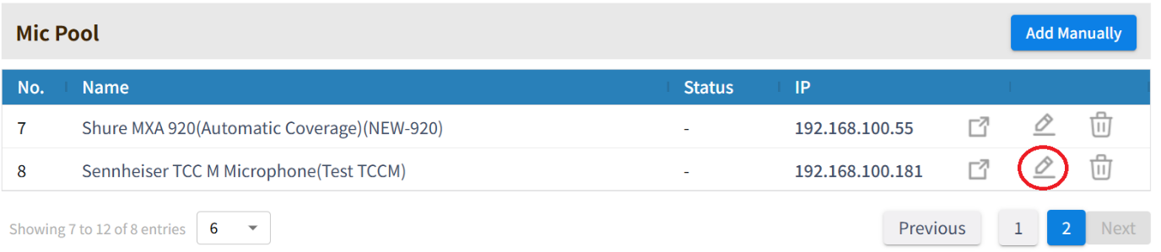

1. Enter the password (set earlier) and click the ‘Save’ button.

The following module options are available:

**Device IP:** IP address of the TCCM device.

**Password:** API password set on the TCCM device.

**Mic Trigger dB:** A zone change will only be triggered if this level is exceeded. The range is -90 to 0 (Default -45).

**Far end detection:** Enable or disable far end detection.

**Zone Configuration**

1. Click the ‘Device Menu’ and then ‘Mic Pool’

1. Click the ‘Add Manually’ button under the ‘Mic Pool’ heading.

1. Select ‘Sennheiser TCC-2’ from the dropdown menu, enter a friendly name and the IP address of the Sennheiser TCC 2 microphone.
2. Click the ‘Add’ button.
3. You will see the microphone listed as below, click the ‘Edit’ icon to access the module settings.

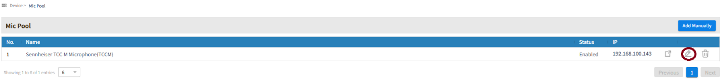

1. Scroll down and select the microphone for which you want to configure zones from the dropdown menu.
2. By default, the V2 mode is used, the legacy V1 mode is no longer recommended.

1. When voice activity is detected, a red dot will indicate the detected position. The dot is plotted using the azimuth angle and beam elevation reported by the microphone. The red dot will only appear if the audio level is above the threshold ‘Mic trigger dB’ set in the microphone’s module setting.
2. Click the ‘Add Zone’ button and add zones as required, the currently selected zone will be shown in red.

1. Click ‘Save’ once you are happy with the zone configuration.

## Sennheiser TCC 2

Preparation

Initial configuration: A router or managed switch with a DHCP server function will be required to set the Network settings.

Network Connections: Install the Sennheiser TCC 2, VoiceTRX100 processor, PTZ cameras and video switcher in the same local area network.

Installation Location: Decide on the installation location for the Sennheiser TCC 2. Choose a location that captures the participants' voices while considering the camera's field of view.

Firmware Updates: Ensure that the Sennheiser TCC 2 and all Datavideo equipment is updated to the latest version before configuration.

Discover the microphone and access the configuration UI

1. Download and install the Sennheiser ‘Control Cockpit’ software <https://www.sennheiser.com/en-us/catalog/applications/assistive-listening-and-audience-engagement/control-cockpit/control-cockpit-111111>
2. Open ‘Control Cockpit’ and navigate to the ‘Devices Tab’
3. If the TCC2 is not listed, you can add it manually using its IP address

1. Click the TCC2 microphones name to access its settings

Zone Settings

The Sennheiser TCC 2 supports two types of zones:

**Exclusion Zones**

Exclusion Zones enable you to eliminate unwanted sources of constant noise. Up to five exclusion zones are supported. It is recommended to exclude any areas that will not be actively used.

Adjust the sliders to set a vertical and horizontal zone. The vertical zone can be adjusted from 0° to 90°, the Horizontal zone can be adjusted from 0° to 360°.

**Priority Zones**

The Priority Zone is used to keep the focus on the moderator's voice. The priority zone take priority over non-priority zones. One priority zone is supported, the ‘Weight’ can be set as follows:

**Mid:** Increases the weighting on the audio output from the selected zone by approximately 1.5 times the normal value.

**High:** Increases the weighting on the audio output from the selected zone by approximately 2 times the normal value.

**Max:** Increases the weighting on the audio output from the selected zone by approximately 3 times the normal value.

**3D Overall View**

The 3D view will display the current beam position (loudest speaker) and priority / exclusion zones in real time.

Priority zones are shown in green; exclusion zones are shown in dark blue. If both types of zone overlap, the exclusion zones will override the priority zone.

Audio Settings

**Installation Type**

Please ensure you set the appropriate installation type.

**Flush Mount:** The microphone array has been installed in or directly underneath the ceiling.

**Suspended mount:** The microphone array has been suspended from the ceiling.

**Noise Gate**

The noise gate function prevents the TCC M microphone from picking up unwanted background noise.

Threshold: The Noise Gate will open the audio output only after the audio level exceeds the set threshold for the set period.

**Sensitivity Threshold**

The Sensitivity Threshold setting lets you adjust the TCC M microphone's sensitivity to background noise to better identify the presenter. Depending on the setting, the sensitivity is either amplified or attenuated.

**Normal(default):** Recommended for speakers with a normal speaking volume.

**Quiet:** Recommended for speakers with a quiet speaking volume. The sensitivity of the microphone is increased.

**Loud:** Recommended for speakers with a loud speaking volume. The sensitivity of the microphone is attenuated.

VoiceTRX100 Configuration

**Connecting the Sennheiser TCC 2 microphone**

1. Click the ‘Device Menu’ and then ‘Mic Pool’

1. Click the ‘Add Manually’ button under the ‘Mic Pool’ heading.

1. Select ‘Sennheiser TCC-2’ from the dropdown menu, enter a friendly name and the IP address of the Sennheiser TCC 2 microphone.

1. Click the ‘Add’ button.
2. You will see the microphone listed as below, click the ‘Edit’ icon to access the module settings.

The following module options are available:

**Device IP:** IP address of the TCC2 microphone.

**Port:** Must match the port number set of the microphone, the default is 45.

**Mic Trigger dB:** A zone change will only be triggered if this level is exceeded. The range is -90 to 0 (Default -45).

**Far end detection:** Enable or disable far end detection.

**Far end detection (Beam Freeze position):** The ‘Home’ zone will be trigger when the microphones beam freeze function is ON. The beam freeze position is dependent on the microphones rotation setting.

**Zone Configuration**

1. By default, the V2 mode is used, the legacy V1 mode is no longer recommended.

1. When voice activity is detected, a red dot will indicate the detected position. The dot is plotted using the azimuth angle and beam elevation reported by the microphone. The red dot will only appear if the audio level is above the threshold ‘Mic trigger dB’ set in the microphones module setting.
2. Click the ‘Add Zone’ button and add zones as required, the currently selected zone will be shown in red.

1. Click ‘Save’ once you are happy with the zone configuration.

## Audio-Technica ATND1061

Preparation

Initial configuration: A router or managed switch with a DHCP server function will be required to set the Network settings.

Network Connections: Install the Audio-Technica ATND1061, VoiceTRX100 processor, PTZ cameras and video switcher in the same local area network.

Installation Location: Decide on the installation location for the Audio-Technica ATND1061. Choose a location that captures the participants' voices while considering the camera's field of view.

Firmware Updates: Ensure that the Sennheiser TCC M and all Datavideo equipment is updated to the latest version before configuration.

Discover the microphone and access the configuration UI

Download and install the Digital Microphone manager software <https://docs.audio-technica.com/eu/DigitalMicrophoneManager-1.0.1-Setup.zip>

Launch the app and set the room size and click the ‘Create’ button 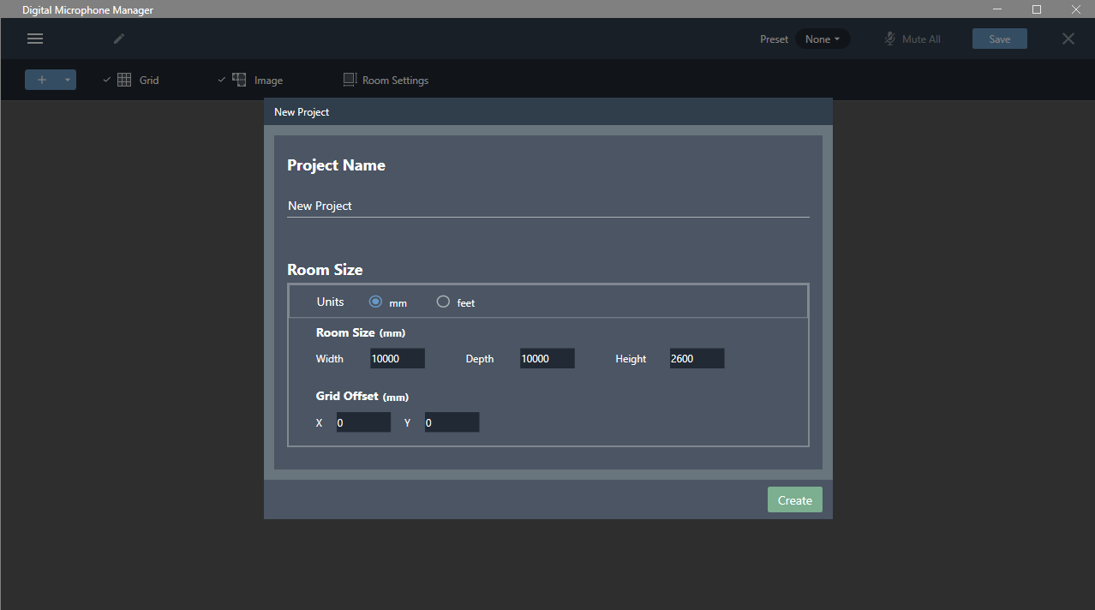

Click the ‘+’ button in the top left corner and select ‘Add Online Device’

Select the microphone and click ‘Add’

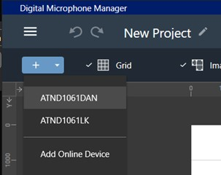

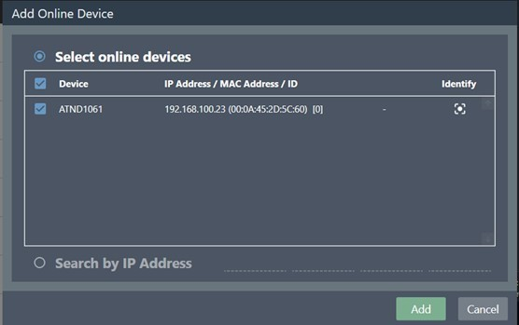

Enable third party access

Click the cog in the top right corner.



Click ‘Network’ and enable all notifications as below.

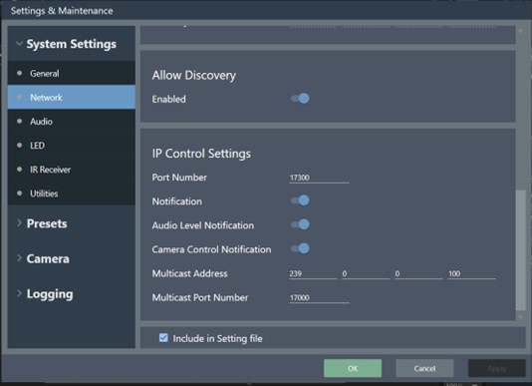

3. Make note of the IP address, you will need it to connect the ATND1061 to the VoiceTRX100 later.

Coverage and Camera Zone configuration

The UI will show a dot where audio is detected, you can use the ‘Mark’ option to mark the talker positions. 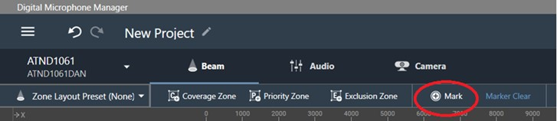

Add coverage and exclusions zones as required. 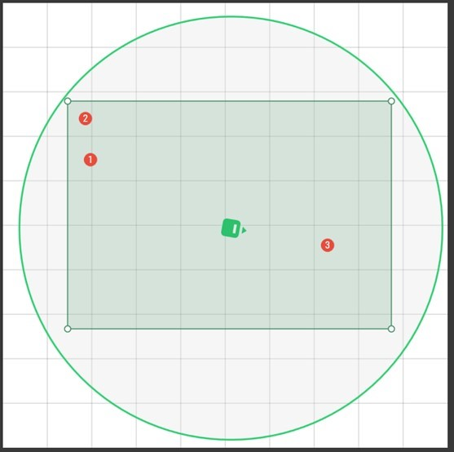

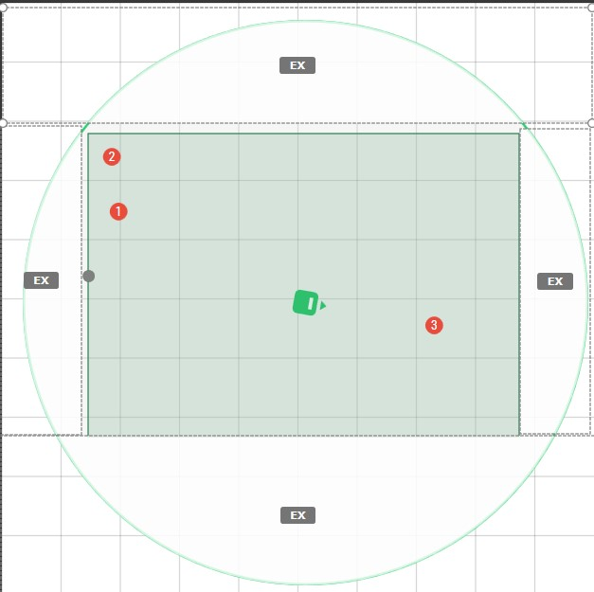

Add camera zones to cover the marked talker positions.

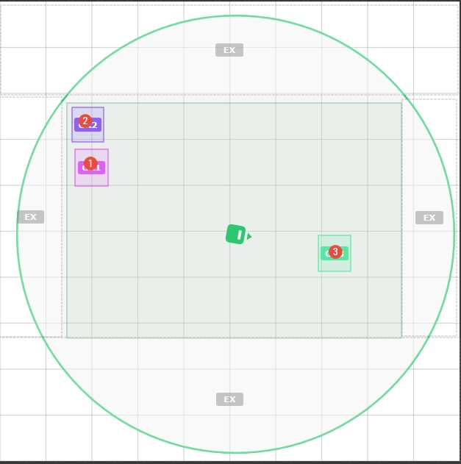

VoiceTRX100 Configuration

**Connecting the Audio-Technica ATND1061 microphone**

1. Click the ‘Device Menu’ and then ‘Mic Pool’

1. Click the ‘Add Manually’ button under the ‘Mic Pool’ heading.

1. Select ‘Audio-Technica ATND 1000 Series’ from the dropdown menu, enter a friendly name and the IP address of the Audio-Technica ATND microphone.

1. Click the ‘Add’ button.
2. You will see the microphone listed as below, click the ‘Edit’ icon to access the module settings.

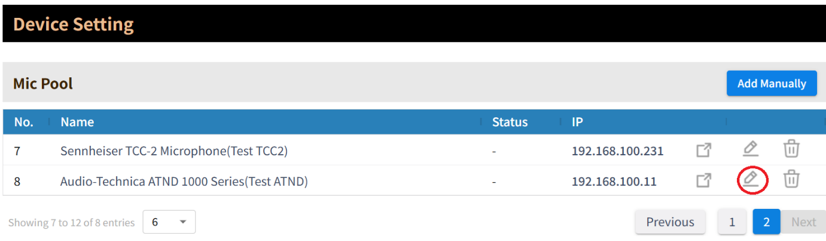

The following module options are available:

**Device IP:** IP address of the ATND microphone.

**Port:** Must match the port number set of the microphone, the default is 17300.

**Zones:** Set the number of zones requires, this should match the number of camera zones set on the microphone.

**Zone Configuration**

Zones 1-15 on the VoiceTRX-100 are automatically mapped to camera zones 1-15 on the ATND 1061.

## Shure MXA 920 (Automatic Coverage)

Preparation

Initial configuration: A router or managed switch with a DHCP server function will be required to set the Network settings.

Network Connections: Install the Shure MXA 920, VoiceTRX100 processor, PTZ cameras and video switcher in the same local area network.

Installation Location: Decide on the installation location for the Shure MXA 920. Choose a location that captures the participants' voices while considering the camera's field of view.

Firmware Updates: Ensure that the Shure MXA 920 and all Datavideo equipment is updated to the latest version before configuration.

Discover the microphone and access the configuration UI

1. Download and install “Shure Web Device Discovery“ software [Device Discovery - Shure Web Device Discovery Application - Shure USA](https://www.shure.com/en-US/products/software/shure_web_device_discovery_application?variant=Shure%2520Web%2520Device%2520Discovery%2520Application%25201.2.9%2520-%2520Windows).
2. Open the software and note the IP address of the Shure MXA 920.

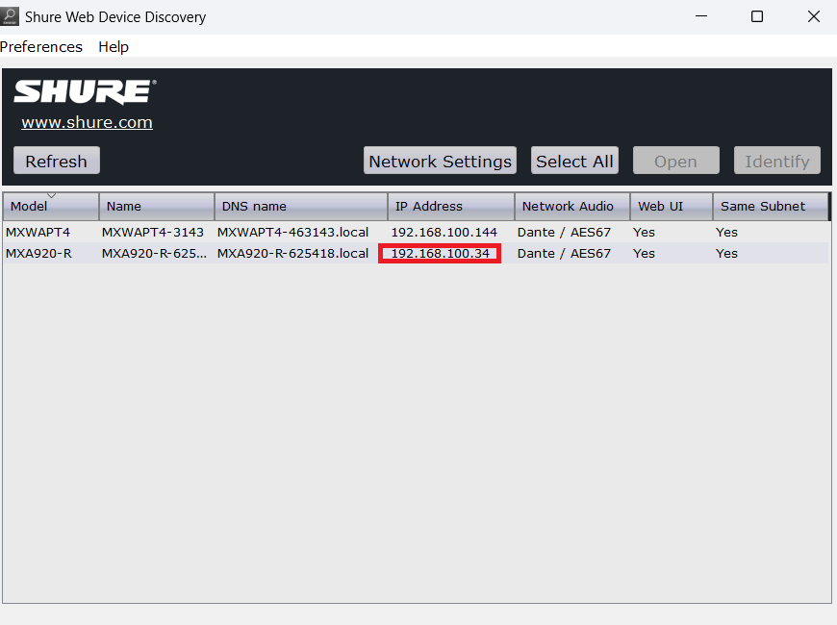

1. Type the IP address into your web browser to access the web interface of the Shure MXA 920.

Coverage

1. ‘Automatic Coverage’ should be turned on.

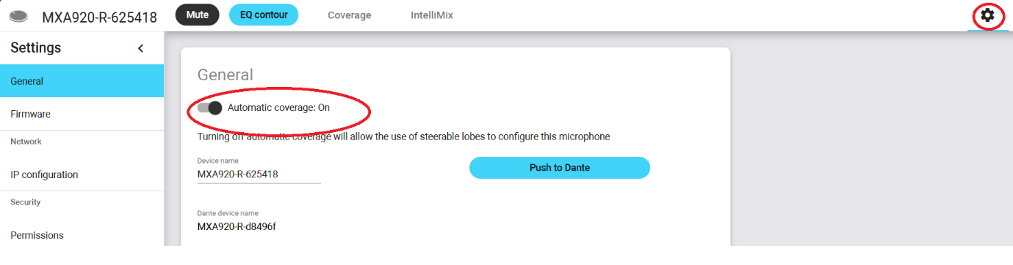

1. Add dynamic and dedicated coverage zones as required. By default, a single 9 x 9 dynamic coverage zone is enabled.

VoiceTRX100 Configuration

**Connecting the Shure MXA 920 microphone**

1. Click the ‘Device Menu’ and then ‘Mic Pool’

1. Click the ‘Add Manually’ button under the ‘Mic Pool’ heading.

1. Select ‘Shure MXA-920 (Automatic Coverage) from the dropdown menu, enter a friendly name and the IP address of the Shure MXA 920 microphone.

1. Click the ‘Add’ button.
2. You will see the microphone listed as below, click the ‘Edit’ icon to access the module settings.

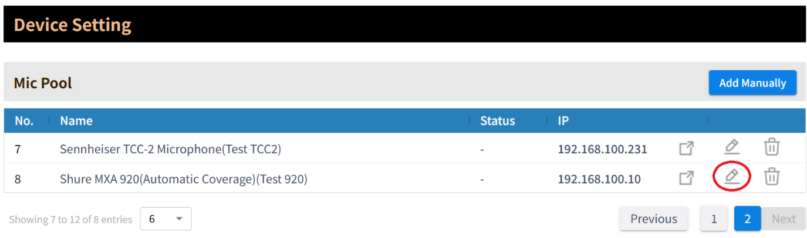

The following module options are available:

**Device IP:** IP address of the Shire MXA 920 microphone.

**Port:** Must match the port number set of the microphone, the default is 2202.

**Array height (cm):** The array height from the floor. It takes on values of 122-914 centimetres (4-30 feet) in 1-centimetre increments.

**Position Update Period (ms):** 100ms to 99999ms.Represents how frequently talker positions should be reported.

These commands control the sensitivity of the algorithm that reports talker positions. Higher sensitivity means the algorithm is easier to trigger and therefore reports more positions.

**Position Sensitivity (Localized):** Controls the amount of localization data that the mic sends.

**Position Sensitivity (VAD):** Controls how sensitive the voice activity detection part of the algorithm is.

**Position Sensitivity (Reflection/Height):** Use to improve localization precision. You must provide an array mounting height to use this setting. Use reflection correction in rooms with many highly reflective surfaces.

**Min Elevation(cm):** Set the minimum elevation, noise from outside this range will be ignored and will not trigger a zone change, use this setting to reduce the chance of noise pollution from above or below.

**Max Elevation(cm):** Set the maximum elevation, noise from outside this range will be ignored and will not trigger a zone change, use this setting to reduce the chance of noise pollution from above or below.

**Far end Trigger dB:** A zone change will only be triggered if this level is exceeded. The range is -90 to 0 (Default -45).

**Far end detection:** Enable or disable far end detection.

**Unit Orientation (From your POV):** Sets the orientation of the microphone from your point of view, this critical so the X and Y coordinates reported by the microphones correlate to the zone configuration UI. The orientation refers to the microphones zero point (directly opposite the ethernet port).

**Zone Configuration**

1. Click the ‘Device Menu’ and then ‘Mic Pool’

1. Scroll down and select the microphone for which you want to configure zones from the dropdown menu.

1. Set Grid Width and height to match the size of the room. You must ensure the grid size is covered by dynamic or fixed coverage areas (previously configured).
2. When voice activity is detected, a red dot will indicate the detected position. The dot will remain in position for the duration of the ‘Home Period’ after the voice activity is no longer detected, this is to help you position the zones. If the dot does not move as expected, please check the “**Unit Orientation (From your POV)”** setting in the module settings.

1. Click the ‘Add Zone’ button and add zones as required, the currently selected zone will be shown in red.

1. Click ‘Save’ once you are happy with the zone configuration.

## Shure MXA 910/920 (Lobe gating mode)

Preparation

Initial configuration: A router or managed switch with a DHCP server function will be required to set the Network settings.

Network Connections: Install the Shure MXA 910/920, VoiceTRX100 processor, PTZ cameras and video switcher in the same local area network.

Installation Location: Decide on the installation location for the Shure MXA 910/920. Choose a location that captures the participants' voices while considering the camera's field of view.

Firmware Updates: Ensure that the Shure MXA 910/920 and all Datavideo equipment is updated to the latest version before configuration.

Discover the microphone and access the configuration UI

1. Download and install “Shure Web Device Discovery“ software [Device Discovery - Shure Web Device Discovery Application - Shure USA](https://www.shure.com/en-US/products/software/shure_web_device_discovery_application?variant=Shure%2520Web%2520Device%2520Discovery%2520Application%25201.2.9%2520-%2520Windows).
2. Open the software and note the IP address of the Shure MXA 910/920.

1. Type the IP address into your web browser to access the web interface of the Shure MXA 920.

Coverage

1. If you are using the Shure MXA 920 ‘Automatic Coverage’ should be turned off.

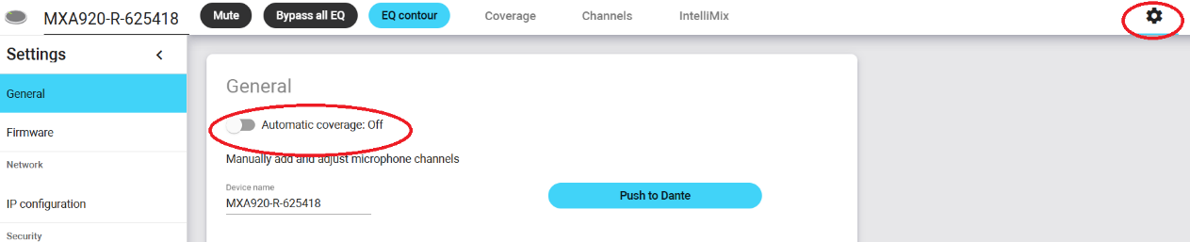

1. Remove any existing channels, leaving only channel 1.

1. Add as many actional channels as required (maximum 8).

Auto Positioning

1. You will need to find someone to speak in each position.
2. Select channel X, then press the ‘Auto position’ button.
3. Press the ‘Listen’ button in the auto position window.

1. The position of channel X will be adjusted automatically.

Lobe width

Set the lobe width of each channel as “Narrow” or “Medium”. This will reduce the area covered by each lobe and increase the accuracy of voice tracking.

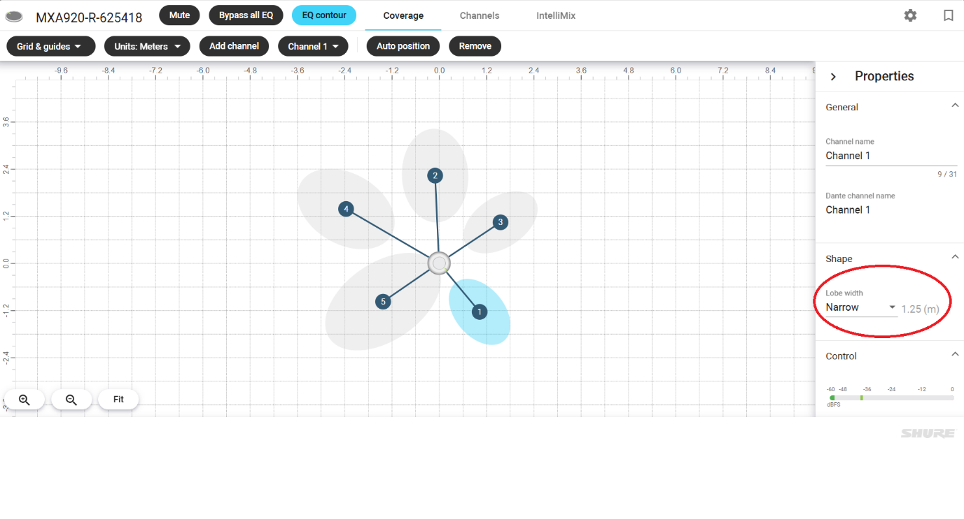

IntelliMix

Navigate to go to the ‘IntelliMix’ tab. The settings below will affect the audio tracking of VoiceTRX-100.

**Priority**

If we enable ‘Priority’ on channel 1 and both channel 1 and channel 2 are talking, the signal of Channel 1 will get priority. For example, if the main speaker is in the position of channel 1, channel 1 can be set with higher priority.

**Always on**

It is not recommended to leave a channel always on when using voice tracking.

**Leave last mic on**

If this feature is enabled, the last active mic will remain active and prevent the VoiceTRX-100 from activating the ‘Home’ zone even if the room is silent.

**Gating Sensitivity**

Changes the threshold of the level at which the gate is opened and VoiceTRX-100 will trigger the associated zone. The higher the number, the more sensitive the trigger will be, and the chance of a zone switch will be increased.

**Channel Testing**

On the IntelliMix tab, you can check if the correct channel is activated when someone speaks in that position. The VoiceTRX-100 maps channels 1-8 to zones 1-8, it relies on the correct channel being activated.

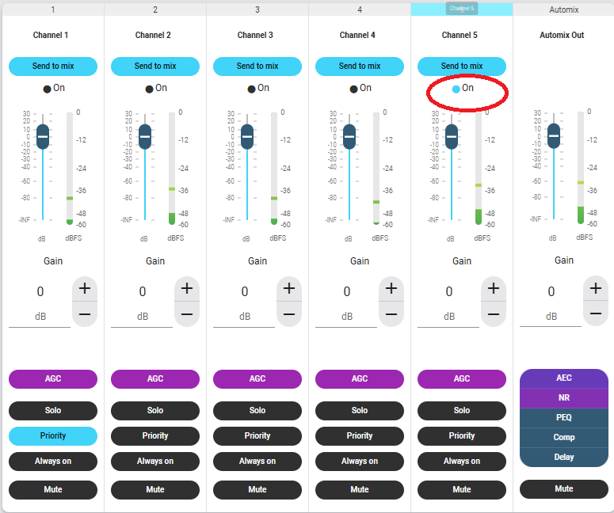

VoiceTRX100 Configuration

**Connecting the Shure MXA 910/920 microphone**

1. Click the ‘Device Menu’ and then ‘Mic Pool’

1. Click the ‘Add Manually’ button under the ‘Mic Pool’ heading.

1. Select ‘Shure MXA-910/920 (Lobe Gating)’ from the dropdown menu, enter a friendly name and the IP address of the Shure MXA 910/920 microphone.

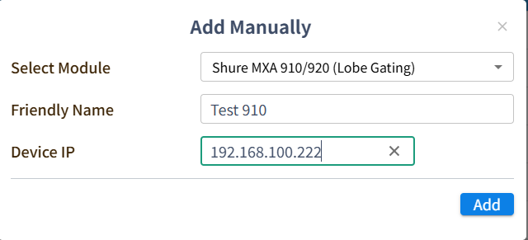

1. Click the ‘Add’ button.
2. You will see the microphone listed as below, click the ‘Edit’ icon to access the module settings.

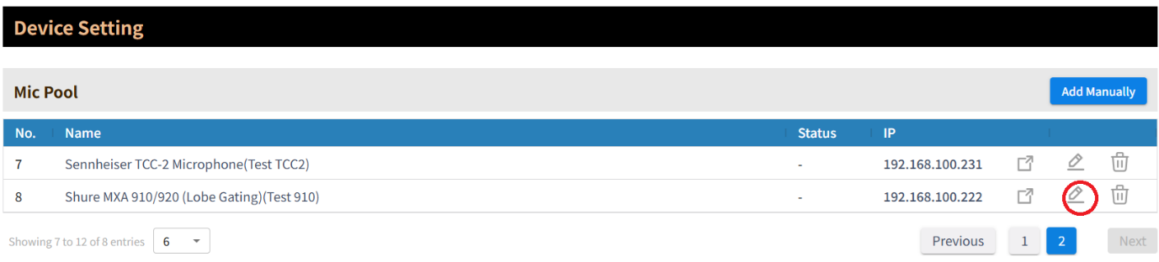

The following module options are available:

**Device IP**: IP address of the MXA 910/920 microphone.

**Port:** Must match the port number set of the microphone, the default is 22022.

**Far end Trigger dB:** A zone change will only be triggered if this level is exceeded. The range is -90 to 0 (Default -45).

**Far end detection:** Enable or disable far end detection.

**Zone Configuration**

Zones 1-8 on the VoiceTRX-100 are automatically mapped to lobes 1-8 on the Shure MXA 910/920.

## Shure MXW

Supported receivers

The following receivers are supported:

* MXWAPT2
* MXWAPT4
* MXWAPT8

Preparation

Initial configuration: A router or managed switch with a DHCP server function will be required to set the Network settings.

Network Connections: Install the Shure MXW receiver, VoiceTRX100 processor, PTZ cameras and video switcher in the same local area network.

Firmware Updates: Ensure that the Shure MXW and all Datavideo equipment is updated to the latest version before configuration.

Discover the receiver and access the configuration UI

1. Download and install “Shure Microflex Wireless” [Microflex Wireless Software - Software Application - Shure United Kingdom](https://www.shure.com/en-GB/products/software/microflex_wireless_software).
2. Open the software, the MXW receiver should be listed.

1. Double click the receiver to access the settings, the default password is ‘admin’.

Switch behaviour

1. Click the ‘Preferences’ tab.
2. Select the desired switch behaviour:

* Push-to-Talk – The switch must he held down to unmute the microphone.
* Toggle – The microphone will be muted and unmuted with each button press.
* Push-to-Mute – The switch must be held down to mute the microphone.

VoiceTRX100 Configuration

**Connecting the Shure MXW receiver**

1. Click the ‘Device Menu’ and then ‘Mic Pool’

1. Click the ‘Add Manually’ button under the ‘Mic Pool’ heading.

1. Select ‘Shure MXW’ from the dropdown menu, enter a friendly name and the IP address of the Shure MXW receiver.

1. Click the ‘Add’ button.
2. You will see the microphone listed as below, click the ‘Edit’ icon to access the module settings.

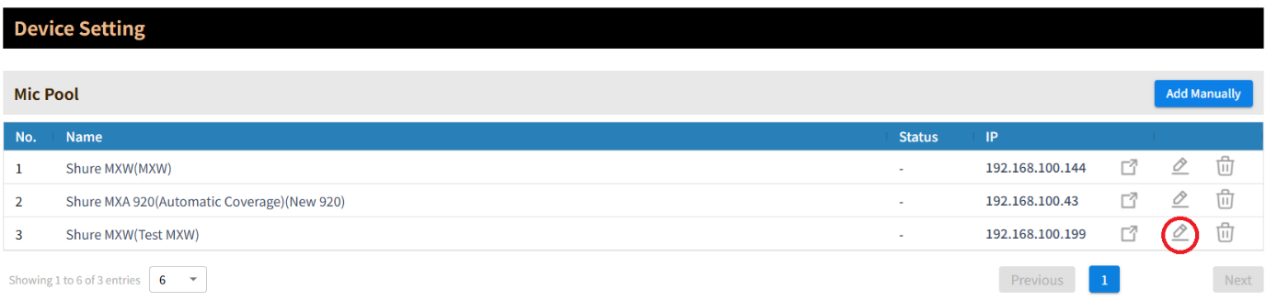

The following module options are available:

**Device IP**: IP address of the MXW receiver.

**Port:** Must match the port number set of the receiver, the default is 2202.

**Logic Trigger Field:** Select if zone changes should be triggered by the microphones mute state or audio level.

**Mic Trigger level:** This setting is only valid when the trigger is set to audio level. A zone change will only be triggered if this level is exceeded. The range is -90 to 0 (Default -45).

**Zone Configuration**

Zones 1-8 on the VoiceTRX-100 are automatically mapped to microphones 1-8 on the MXW receiver.

If more than one microphone is active, the ‘Home’ zone will be triggered

## Shure MXCW

Preparation

Initial configuration: A router or managed switch with a DHCP server function will be required to set the Network settings.

Network Connections: Install the Shure MXCW conference unit, VoiceTRX100 processor, PTZ cameras and video switcher in the same local area network.

Firmware Updates: Ensure that the Shure MXCW and all Datavideo equipment is updated to the latest version before configuration.

Discover the conference unit and access the configuration UI

1. Download and install “Shure Web Device Discovery“ software [Device Discovery - Shure Web Device Discovery Application - Shure USA](https://www.shure.com/en-US/products/software/shure_web_device_discovery_application?variant=Shure%2520Web%2520Device%2520Discovery%2520Application%25201.2.9%2520-%2520Windows).
2. Open the software and note the IP address of the Shure MXCW receiver.

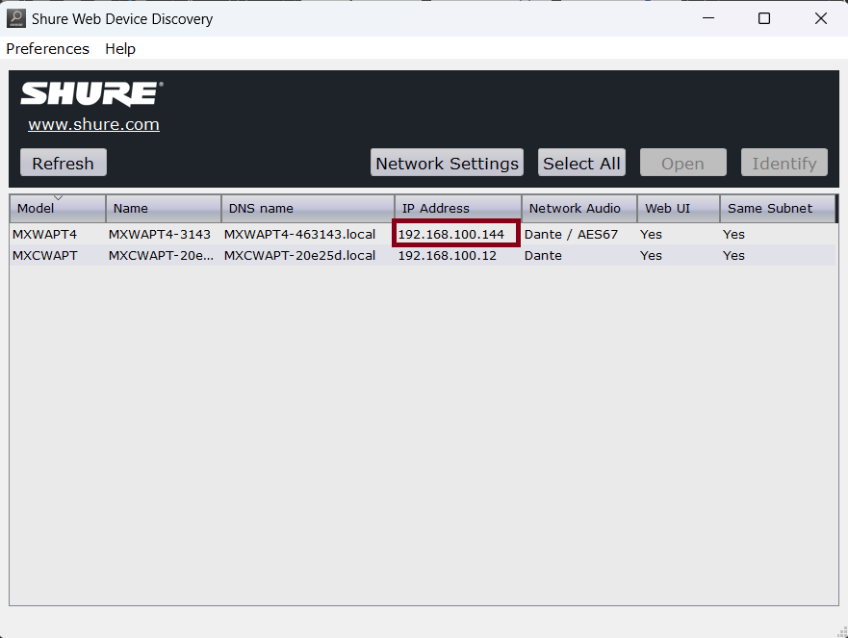

1. Type the IP address into your web browser to access the web interface of the Shure MXCW receiver.

Meeting Controls

The MXCW system allows up to 8 active speakers. Once the speaker list is full, participants must wait until their turn to speak. If they attempt to speak before their turn, their microphone LED ring flashes momentarily and then turns off as a reminder.

There are several meeting controls that will affect the way the VoiceTRX100 system behaves.

To configure the meeting controls:

1. Click the ‘Meeting Controls’ tab.
2. Set the speak mode and number of active speakers and active speakers as required:

* Speak mode – The speak mode determines the way the participants use their microphones in a group setting.

* Maximum number of active speakers – This setting limits how many speakers can be active at once (including chairpersons).
* Maximum number of delegate speakers – This setting limits how many delegate speakers can be active at once, this setting does not limit chairpersons.
* Maximum Requests: Total number of participants that can be in the request queue. This is only available in Manual and FIFO mode.

1. Click the ‘Advanced’ tab on the left of the screen.
2. Set the active speaker interruption as required:

* Not allowed
* Higher speak priority allowed (default)
* Equal or higher speak priority allowed

Please consult the ‘Speak Priority’ section of the Shure MXCW manual for more information on adjusting individual participants' priority.

VoiceTRX100 Configuration

**Connecting the Shure MXCW conference unit**

1. Click the ‘Device Menu’ and then ‘Mic Pool’

1. Click the ‘Add Manually’ button under the ‘Mic Pool’ heading.

1. Select ‘Shure MXCWAPT Microflex’ from the dropdown menu, enter a friendly name and the IP address of the Shure MXCW receiver.

1. Click the ‘Add’ button.
2. You will see the microphone listed as below, click the ‘Edit’ icon to access the module settings.

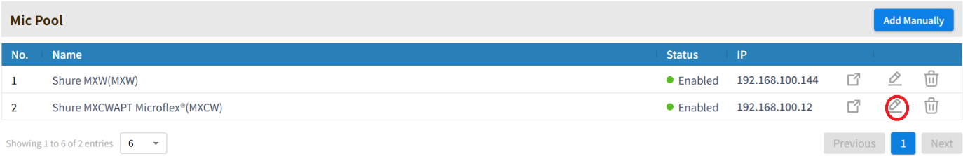

The following module options are available:

**Device IP**: IP address of the MXCW receiver.

**Port:** Must match the port number set of the receiver, the default is 2202.

**Zone Configuration**

Zones 1-125 on the VoiceTRX-100 are automatically mapped to microphones 1-125 on the MXCW receiver.

**Behaviour**

Total speakers’ mode

-If more than one microphone is active, the ‘Home’ zone will be triggered, unless the chairperson is active, in that case the chairperson will be prioritized.

-If more than one chairperson is active, the ‘Home’ zone will be triggered.

Last speaker mode

-If more than one microphone is active, the last one to go active will be prioritized unless the chairperson is active, in that case the chairperson will be prioritized.

-If more than one chairperson is active, the last one to go active will be prioritized.

## Sennheiser Speech line

Supported receivers

All SL MCR DW receivers are supported.

Preparation

Initial configuration: A router or managed switch with a DHCP server function will be required to set the Network settings.

Network Connections: Install the Sennhesier SLDW receiver, VoiceTRX100 processor, PTZ cameras and video switcher in the same local area network.

Firmware Updates: Ensure that the Sennheiser SLDW receiver and all Datavideo equipment is updated to the latest version before configuration.

Discover the microphone and access the configuration UI

1. Download and install the Sennheiser ‘Control Cockpit’ software <https://www.sennheiser.com/en-us/catalog/applications/assistive-listening-and-audience-engagement/control-cockpit/control-cockpit-111111>
2. Open ‘Control Cockpit’ and navigate to the ‘Devices Tab’
3. If the SLDW receiver is not listed, you can add it manually using its IP address

1. Click the SLDW receiver name to access its settings

Switch behaviour

The ‘Mute mode’ is set per microphone.

1. Select the microphone in the Sennheiser Control Cockpit
2. Select the desired mute mode:

* Switch inactive – The microphone will always be unmuted
* Switch active – The microphone will be muted and unmuted with each button press.
* Push-to-talk – The switch must be held down to unmute the microphone.
* Push-to-Mute – The switch must be held down to mute the microphone.

VoiceTRX100 Configuration

**Connecting the Sennheiser SLDW receiver**

1. Click the ‘Device Menu’ and then ‘Mic Pool’

1. Click the ‘Add Manually’ button under the ‘Mic Pool’ heading.

1. Select ‘Sennheiser Speechline’ from the dropdown menu, enter a friendly name and the IP address of the SLDW receiver.

1. Click the ‘Add’ button.
2. You will see the microphone listed as below, click the ‘Edit’ icon to access the module settings.

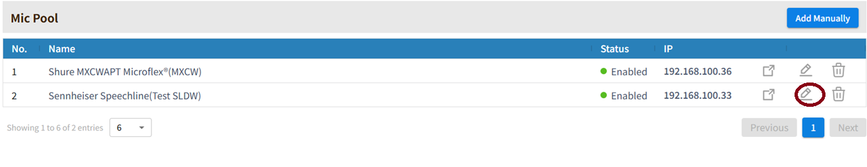

The following module options are available:

**Device IP**: IP address of the MXW receiver.

**Port:** Must match the port number set of the receiver, the default is 2202.

**Logic Trigger Field:** Select if zone changes should be triggered by the microphones mute state or audio level.

**Mic Trigger level:** This setting is only valid when the trigger is set to audio level. A zone change will only be triggered if this level is exceeded. The range is -90 to 0 (Default -45).

**Zone Configuration**

Zones 1-4 on the VoiceTRX-100 are automatically mapped to microphones 1-4 on the SLDW receiver.

If more than one microphone is active, the ‘Home’ zone will be triggered

## Generic TCP Input

The generic TCP input module works like a fake microphone, allowing third party DSPs and audio consoles to trigger zones on the VoiceTRX-100.

VoiceTRX100 Configuration

**Configuring the generic TCP input module**

1. Click the ‘Device Menu’ and then ‘Mic Pool’

1. Click the ‘Add Manually’ button under the ‘Mic Pool’ heading.

1. Select ‘Generic TCP Input from the dropdown menu, enter a friendly name and change the port number if you wish.

1. Click the ‘Add’ button.
2. You will see the microphone listed as below, click the ‘Edit’ icon to access the module settings.

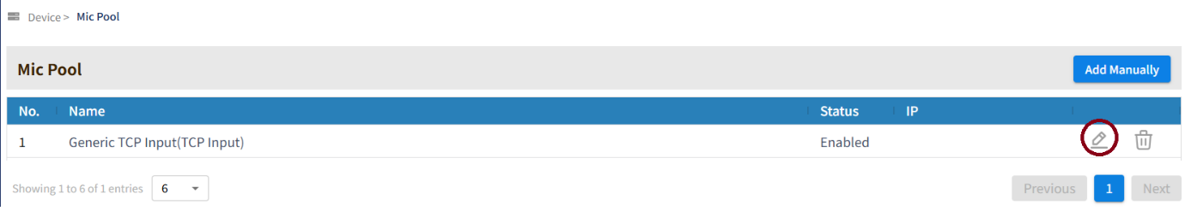

The following module options are available:

**TCP Port:** The TCP port used to connect with the module.

**No. of Mics:** The number of virtual mics available to control.

**Module Commands**

|  |  |  |
| --- | --- | --- |
| **Command** | **Command Packet** | **Description** |
| Turn on all mics | <MIC 0 ON> | Turn on all mics (the number of mics can be configured in the module settings) |
| Turn off all mics | <MIC 0 OFF> | Turn off all mics (the number of mics can be configured in the module settings) |
| Get status of all mics | <MIC 0 STATUS> | Get the status (ON/OFF) of all mics (the number of mics can be configured in the module settings) |
| Get status of individual mic | <MIC 1 STATUS> | Get the status (ON/OFF) of an individual mic, replace 1 with the mic number. |
| Turn on individual mic | <MIC 1 ON> | Turn on an individual mic, replace 1 with the mic number. |
| Turn off individual mic | <MIC 1 OFF> | Turn off an individual mic, replace 1 with the mic number. |

## Audio-Technica ATUC-50/ATUC-IR

Preparation

Initial configuration: A router or managed switch with a DHCP server function will be required to set the Network settings.

Network Connections: Install the ATUC conference unit, VoiceTRX100 processor, PTZ cameras and video switcher in the same local area network.

Firmware Updates: Ensure that the ATUC and all Datavideo equipment is updated to the latest version before configuration.

Discover the conference unit and access the configuration UI

1. The IP address of the conference unit can be obtained using its LCD display Set > Operator > System Info > IP Address.
2. Type the IP address into your web browser to access the web interface of the Shure MXCW receiver.

1. Select ‘Administrator’ and clock ‘Login’.

Meeting Controls

The ATUC-50 and ATUC-IR systems allows up to 10 active speakers.

There are several meeting controls that will affect the way the VoiceTRX100 system behaves.

To configure the meeting controls:

1. Click the ‘Settings and Maintenance’ button.
2. Select ‘Install Settings’ then ‘Conference’
3. Set the conference mode and number of active speakers and active speakers as required:

* Free Talk

In this mode, attendees can talk when the (talk) button is pressed or when their DUs automatically detect their voices.

* Request Talk

In this mode, attendees request to talk by pressing the (talk) button on the DU and will be permitted to talk by the steering committee.

The steering committee can also reject the talk request.

To operate the conference in this mode, connect the CU to a control device such as a computer.

* Full Remote

In this mode, utterances are totally controlled via Web Remote. The DU (talk) button operations will be disabled.

To operate the conference in this mode, connect the CU to a control device such as a computer.

1. Set the ‘Override mode’ as required:

* FIFO (First-In First-Out):

Cuts short the speaker who was least recently permitted to talk and permits the person who has just pressed the (talk) button to talk.

* LIFO (Last-In First-Out):

Cuts short the speaker who was most recently permitted to talk and permits the person who has just pressed the (talk) button to talk.

* No Override: (unelectable while in [Request Talk] Mode or [Full Remote] Mode)

The person who has just pressed the (talk) button will be in talk standby and will be permitted to talk when his/her turn comes.

1. Set the ‘Mic on trigger’ as required:

* Button toggle – Toggle muted and unmuted states
* Push to talk – Press and hold to unmute
* Voice – Automatically turn on the microphone when a voice is detected. When this mode is selected you must also set the ‘Mic ON Hold Time’ to adjust how long the microphone will stay on when no voice is detected.

**Note:** When using voice detection, you can adjust the ‘Voice Detection Sensitivity’ under the ‘DU/CU’ menu. The ‘Auto Mic OFF’ option can be used to achieve the same when using button toggle or push to talk modes.

VoiceTRX100 Configuration

**Connecting the ATUC-50/ATUC-IR conference unit**

1. Click the ‘Device Menu’ and then ‘Mic Pool’

1. Click the ‘Add Manually’ button under the ‘Mic Pool’ heading.

1. Select ‘Audio-Technica ATUC 50/IR Series’ from the dropdown menu, enter a friendly name and the IP address of the ATUC-50/IR receiver.

1. Click the ‘Add’ button.
2. You will see the microphone listed as below, click the ‘Edit’ icon to access the module settings.

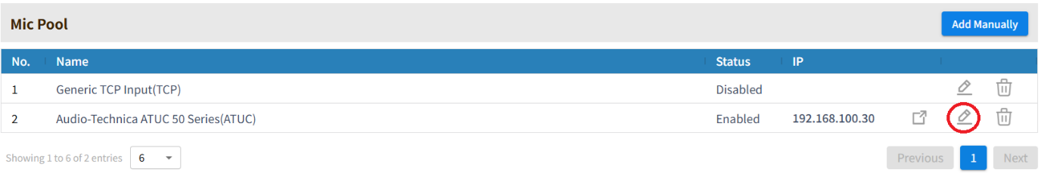

The following module options are available:

**Device IP**: IP address of the ATUC-50/IR receiver.

**Port:** Must match the port number set of the receiver, the default is 17300

**Priority Mode:** Defines what conditions must be met for the VoiceTRX-100 to treat a DU as a priority DU**.**

**Zone Configuration**

1. Click the ‘Device Menu’ and then ‘Mic Pool’

1. Scroll down and select the microphone for which you want to configure zones from the dropdown menu.
2. By default, ATUC-50 DUs will be ordered using their topology number (order in the chain) and ATUC-IR DUs will be ordered by their device ID, however you can modify the zone assigned to each DU using the interface shown below.

**Note:** The DU list is updated every 10 seconds.

**Behaviour**

-If more than one microphone is active, the last one to go active will be prioritized unless a priority microphone is active, in that case the priority microphone will be prioritized.

-If more than one priority microphone is active, the last one to go active will be prioritized.

# Switcher Modules

## Datavideo iCast-10NDI

Preparation

Network Connections: Ensure the VoiceTRX100 processor and iCast-10NDI are in the same local area network.

Firmware Updates: Ensure that Datavideo equipment is updated to the latest version before configuration.

VoiceTRX100 Configuration

**Connecting a Datavideo iCast-10NDI**

1. Click the ‘Device Menu’ and then Switcher Pool’

1. Click the ‘DVIP Scan’ button under the ‘Switcher Pool’ heading.



1. Select the iCast-10NDI from the list and click the ‘Add’ button.

1. You will see the switcher listed as below, click the ‘Edit’ icon to access the module settings.

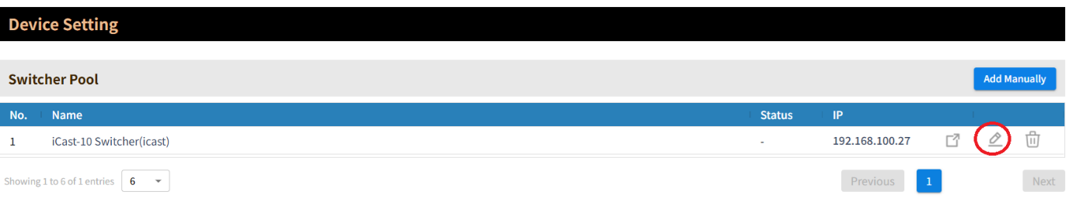

1. Enter the username and password of the iCast-10 in the module settings and click the ‘Save’ button. The default values are User: admin Password: 000000.

The following module options are available:

**Device IP**: IP address of the iCast-10NDI

**Username:** Username of the iCast-10 NDI

**Password:** Password of the iCast-10NDI

**Optimising the timeout period**

By default, the icast-10 requires that the VoiceTRX-100 re-authenticate every 20 minutes, this can cause the system to perform slowly. To change this setting:

1. Click the button shows below to access the iCast-10 WebUI.

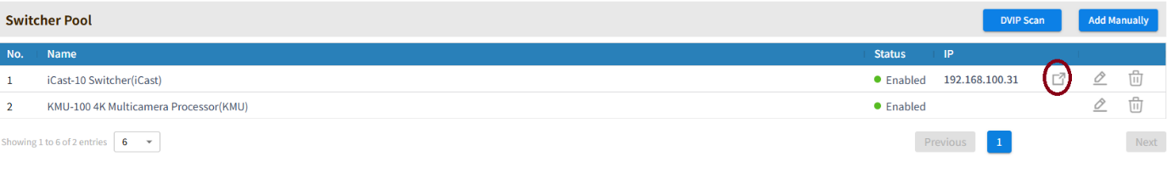

1. Login, the default values are User: admin Password: 000000.

1. Click the ‘System’ tab, scroll down and change the ‘Timeout Period’ to ‘Never;.

1. Click ‘Apply’, you will be automatically logged out once the setting is applied.

## Datavideo KMU-100+

Preparation

Physical Connections: Connect the VoiceTRX100 processor to the KMU-100 with the supplied RJ45 to D9 RS422 cable.

Firmware Updates: the KMU-100 has the latest KMU100+ firmware installed before configuration. The KMU-100+ firmware can be downloaded here [KMU-100 4K Multicamera Processor | Datavideo | Datavideo | Professional end-to-end solutions provider for your live video production.](https://www.datavideo.com/global/product/KMU-100).

VoiceTRX100 Configuration

**Connecting a Datavideo KMU-100+**

1. Click the ‘Device Menu’ and then Switcher Pool’

1. Select ‘KMU-100 4K Multicamera Processor’ from the dropdown menu, enter a friendly name and select the RS422 port.

1. Click the ‘Add’ button.
2. You will see the microphone listed as below, click the ‘Edit’ icon to access the module settings.

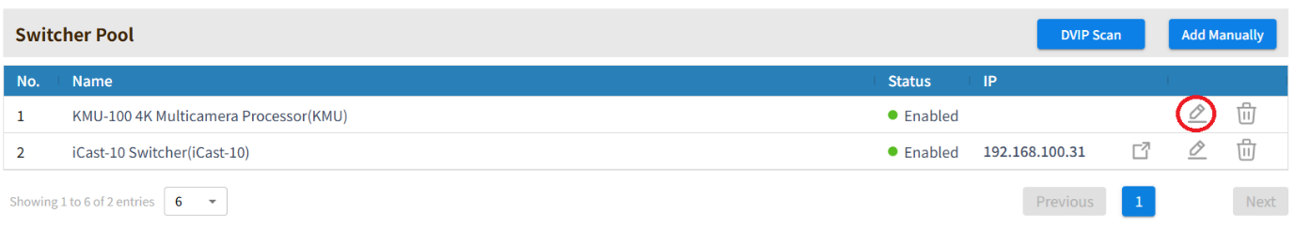

The following module options are available:

**Select Serial Port**: Select the RS422 serial port to which the KMU-100 is connected.

## Datavideo SE-2600/3200/4000 series

Preparation

Network Connections: Ensure the VoiceTRX100 processor and SE series switcher are in the same local area network.

Firmware Updates: Ensure that Datavideo equipment is updated to the latest version before configuration.

VoiceTRX100 Configuration

**Connecting a Datavideo SE series switcher**

1. Click the ‘Device Menu’ and then Switcher Pool’

1. Click the ‘DVIP Scan’ button under the ‘Switcher Pool’ heading.

1. Select the SE series switcher from the list and click the ‘Add’ button.

1. You will see the switcher listed as below, click the ‘Edit’ icon to access the module settings.

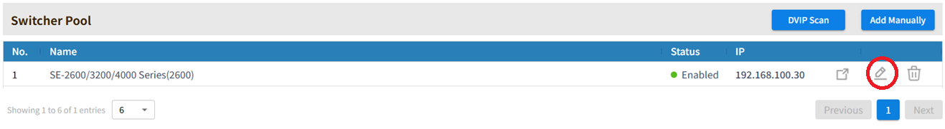

1. Enter the username and password of the iCast-10 in the module settings and click the ‘Save’ button. The default values are User: admin Password: 000000.

The following module options are available:

**Device IP**: IP address of the SE series switcher

## Internal NDI SwitchHub

**Please Note:** The NDI SwitchHub function must be licensed on your VoiceTRX-100 device, you can check if the NDI license is installed via the ‘Licenses’ tab of the WebUI.

VoiceTRX100 Configuration

**NDI router setup**

1. Click the ‘Device Menu’ and then Switcher Pool’

1. Click the ‘Add manually’ button under the ‘Switcher Pool’ heading.

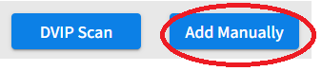

1. Select ‘NDI Router’ from the dropdown menu, enter a friendly name and select the NDI output name.

1. You will see the NDI SwitchHub listed as below, click the ‘Edit’ icon to access the module settings.

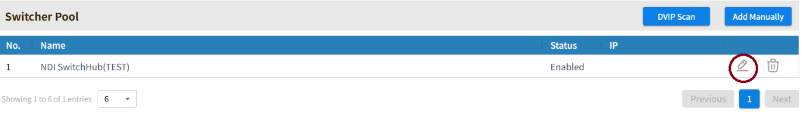

The following module options are available:

**NDI Output Name**: The switched video output of the VoiceTRX-100 will appear on your network with this friendly name.

# Camera Modules

## Datavideo PTC Series

Preparation

Network Connections: Ensure the VoiceTRX100 processor and PTZ cameras are in the same local area network.

Firmware Updates: Ensure that Datavideo equipment is updated to the latest version before configuration.

VoiceTRX100 Configuration

**Connecting a Datavideo PTC series camera**

1. Click the ‘Device Menu’ and then ‘Camera Pool’

1. Click the ‘DVIP Scan’ button under the ‘Camera Pool’ heading.



1. Select the camera from the list and click the ‘Add’ button.
2. You will see the camera listed as below, click the ‘Edit’ icon to access the module settings.

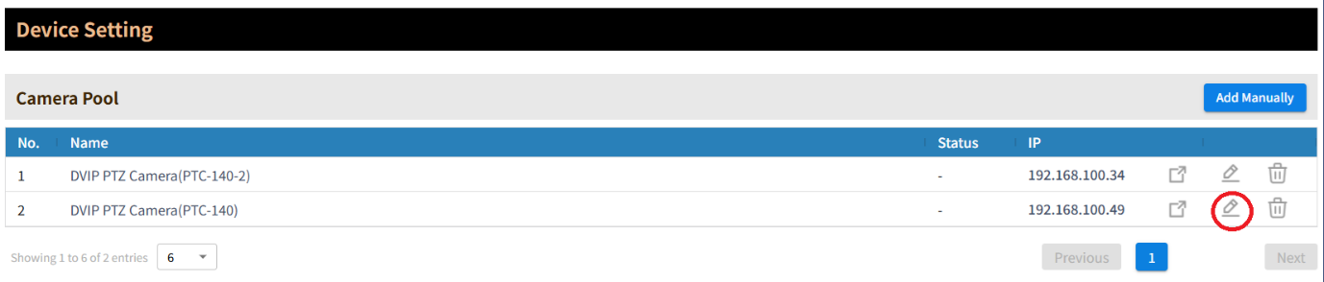

The following module options are available:

**Device IP**: IP address of the PTC series camera.

**RTSP Stream path:** Required for the live video preview to be displayed on the VoiceTRX-100 processor, select your camera series.

# Actions

## Simple Mode

Simple mode is designed to facilitate fast and easy setup for common applications. When simple mode is used, Advanced Mode logic is also generated, this means that you could use Simple Mode to create a base configuration and switch to Advanced Mode to customise it.

For detailed instructions on how to use simple mode, please see the online training course on the Datavideo Academy [www.datavideoacademy.com](http://www.datavideoacademy.com).

## Advanced Mode

Advanced Mode allows for the creation of custom logic using IF, AND, OR and ELSE IF statements. Logic is run every time a microphone zone changes.

**Please Note:** Advanced mode is primarily intended for certified Datavideo personnel, the creation of advanced logic is outside the scope of Datavideo standard support obligations.

# Network

**DHCP:** Turn DHCP client mode ON and OFF, this must be turned off in order to set a static IP address.

**IP Address:** Displays the current IP address in both DHCP ON and DHCP OFF modes. When DHCP is OFF this field is editable, you can enter the static IP address of your choice.

**Network Mask:** In CIDR format, for example a mask of 255.255.255.0 should be entered as 24 (24 bit mask).

**Gateway:** The IP address of your internet gateway, usually your router.

**Primary DNS:** Primary DNS (Domain Name) server.

**Secondary DNS:** Secondary DNS (Domain Name) server.

**Mac Address:** Displays the units unique MAC (hardware address).

**Please Note:** The VoiceTRX-100 must have a valid gateway and DNS servers to check for firmware updates.

# System

**Device Name:** Customise the devices hostname, this is used or DVIP discovery.

**Version:** Displays the devices current firmware version. If the device has access to the interne, it will check for update every 10 minutes and display a message should an update be available.

**Please Note:** The VoiceTRX-100 must have a valid gateway and DNS servers to check for firmware updates.

**HDMI Output 1 & HDMI Output 2**

Resolution: Set the HDMI ports output resolution and framerate

Content: Currently only the option to display the configuration UI is available.

**Trigger Period (ms):** The amount of time in milliseconds that a microphone or microphone position must be active before a zone change is triggered. A camera preset recall will only commence on zone change.

**Switch delay (ms):** The amount of time in milliseconds between a camera being in position and the connected switcher switching to that cameras input. A small switch delay can be useful to allow the cameras autofocus to settle. A larger switch delay can be used with the ‘Home First’ switch mode, this allows a lower Trigger Period to be used to avoid delaying camera movements while still avoid excessive switching or false triggers. Switch delay is currently supported by the iCast-10NDI switcher only.

**Home Period (ms):** The amount of time in milliseconds before the ‘Home’ zone is triggered after no other zones are active (the room is quiet).

**Microphone Tie:** Select the primary microphonewhen more than one microphone module is in use.

**Far end period (ms):** The amount of time in milliseconds before the ‘Home’ zone is triggered when the far end is active. Available for microphones that support far end detection only.

**Far end trigger (dB):** Please see the ‘Far end detection’ section of this guide for more information.

**Audio tracking enabled:** Enable or disable ‘Actions’ being executed on zone change.

**Preset Abort:** When enabled, connected Datavideo PTZ cameras will be allowed to abort (cancel) a preset recall request if a zone change occurs during preset recall, this allows the system to be more responsive to zones change. This option is enabled by default and should only be disabled when advised by support personnel for troubleshooting purposes.

# Microphone Tie

Microphone tie must be enabled if you are using more than once microphone or receiver to control the same switcher and cameras. Microphone tie mode avoids multiple microphones attempting to execute actions at the same time.

If more than one microphone is active at the same time, the ‘Home’ zone on the primary microphone will be triggered. ‘Home’ zone actions should only be configured for the primary microphone.

## Configuration

1. The primary microphone can be selected from the ‘System’ page
2. ‘Home’ zone actions only need to be configured for primary microphone.
3. Adjust the ‘Home Period’ ‘Trigger Period’ and ‘Switch delay’ as required, please see the best practices section below.

## Behaviour and best Practices

* When using ceiling microphones, the zones should be setup to avoid overlap wherever possible. Overlap is when there is a position that triggers zones on more than one microphone. Exclusion zones or restricted coverage areas can be used to prevent overlap (microphone dependant).
* When microphone tie mode is enabled, a microphone is considered active if it’s not on the ‘Home’ zone.
* If more than one microphone is active, the ‘Home’ zone actions are triggered on the primary microphone only.
* When mic tie is enabled, the ‘Home’ zone actions of the primary microphone are only triggered when all microphones are inactive.
* If any microphone reports it has multiple active (-3) the ‘Home’ zone actions are triggered on the primary microphone.
* If any microphone reports it has far end active (-2) the ‘Home’ zone actions are triggered on the primary microphone.
* If you are using a microphone with build in far end detection capability, you must have the far end reference routed to the primary microphone.
* A dedicated ‘Home’ zone (wide shot) camera is recommended when using microphone tie mode.

# Far End Detection

Far end detection allows the VoiceTRX100 to detect when the far end of a conference call is active and trigger actions accordingly, a typical use case would be to force the room to the ‘Home’ zone (wide shot) when the far end has been active for a certain period.

The VoiceTRX100 supports far end detection via supported microphones or universally using a support DANTE input adapter.

Far end detection via the microphones AEC or reference input should only be used where a DANTE input adapter cannot be used, the DANTE input adapter is the preferred method.

## Supported DANTE adapters

The Dante AVIO adapter, model number ADN0005 is supported by VoiceTRX100.

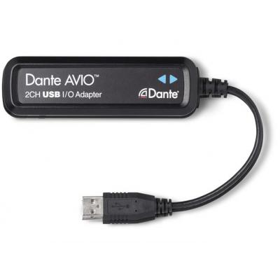

## Configuration

1. Connect the Dante AVIO adapter to one of the two USB ports on the rear of the VoiceTRX-100.
2. Connect the Ethernet connection on the Dante AVIO adapter to the same network as the far end audio source, usually your Dante DSP.
3. Route the audio from the far end to the Dante AVIO input using your DSP and the Dante controller application. If you are routing two channels of audio, use both the left and right channels of the AVIO adapter.

1. Navigate to the VoiceTRX100 ‘System’ tab and set the ‘Far end Period’ and far end Trigger (dB) values as required.

For the far end to be marked as active, and subsequently all microphones to be forced to the ‘Home’ zone, the audio level must be above the ‘Far end Trigger’ threshold in dB for the ‘Far end Period’.

You can check the current dB value from the status on the ‘Dashboard’ tab.

## Behaviour

For the far end to be marked as active, and subsequently all microphones to be forced to the ‘Home’ zone, the audio level must be above the ‘Far end Trigger’ threshold in dB for the ‘Far end Period’.

Once the far end is active, it will stay active for the ‘Far end Period’ at minimum. We sample the audio input from the Dante AVIO adapter every 500ms, if it’s over the ‘Far end Trigger’ threshold we increment to the period, if its less then we decrement.

While the far end is active, local zone changes are blocked, VoiceTRX100 will stay on the ‘Home’ zone it cannot be interrupted.

# Profile

Profiles contain all modules, module settings and actions. You can save and load profiles using the buttons below or the DVIP Control Protocol.

# DVIP Control Protocol

The VoiceTRX-100 supports control from third party control systems over using our IP control protocol (DVIP).

## Discovery and IP configuration

The DVIP Network Configuration Tool can be downloaded from the link below, this tool allows you to discover and configure the network settings of all DVIP devices.

<https://www.datavideo.com/global/product/DVIP>

## DVIP command structure

The DVIP Ethernet Control Guide can be downloaded from the link below.

<https://www.datavideo.com/global/product/DVIP>

The VoiceTRX-100 accepts control command packets overt TCP port 5002. Please pay particular attention to the packet structure, the first two bytes define the packet length.

For example, to turn audio tracking on the complete packet would be as below.

0x0, 0x8, 0x81, 0x0a, 0x11, 0x54, 0x02, 0xff

The command packet is 6 bytes, plus the additional two bytes for packet length = 8 bytes or 0x8.

## Device specific commands

|  |  |  |
| --- | --- | --- |
| Command | Command Packet | Description |
| Audio tracking on | 81 0a 11 54 02 ff | Enable execution of actions |
| Audio tracking off | 81 0a 11 54 03 ff | Disable execution of actions |
| Check tracking status | 81 09 7E 11 54 FF | p: 02: On 03: Off |
| Recall profile | 81 0A 0F 0F 0p 0q FF | Load a user profile. pq : Profile Number 01h ~ FFh |
| Get current profile number | 81 09 7E 0A 0F 0F FF | Get the number of the currently loaded profile. |

# HTTP Control Protocol

|  |  |  |
| --- | --- | --- |
| Command | Command Structure | Description |
| Audio tracking on | http://your.ip/control?feature=tracking&value=on | Enable execution of actions |
| Audio tracking off | http://your.ip/control?feature=tracking&value=off | Disable execution of actions |
| Recall profile | http://your.ip/control?feature=preset_load&value=1 | Load a user profile. Profiles contain actions and hardware configuration. Replace 1 with preset number. |

# Factory Reset

Hold in the reset pin for 10 seconds, this will reset the default username and password and reset the network to DHCP.